

**Report on SONET**

**(CSE-317)**

Group No: **07** Date: 22-10-2019

Section: **B**

Program: CSE-17

Team Members:

1. Ayon Roy (201714018)
2. M Aqib Alfaz (201714024)
3. Md. Nafiz Imtiaz Saimon (201714034)
4. Md. Shariar Azad (201714037)

**Topics Covered By:**

*-In Sequence:*

* Md. Shariar Azad
  + Introduction of SONET
  + Why SONET is called a Synchronous Network?
* Ayon Roy
  + Brief description of SONET Architecture
  + SONET Network Elements
  + SONET Connections
* M Aqib Alfaz
  + SONET Layers
  + SONET Framing and Framing Techniques
* Md. Nafiz Imtiaz Saimon
  + Advantages of SONET
  + Disadvantages of SONET

**Introduction**

Synchronous optical networking (SONET) is a standardized digital communication protocol that is used to transmit a large volume of data over relatively long distances using a fiber optic medium. With SONET, multiple digital data streams are transferred at the same time over optical fiber using LEDs and laser beams. At low transmission rate data can also be transferred via an electrical interface. The method was developed to replace the plesiochronous digital hierarchy (PDH) system for transporting large amounts of telephone calls and data traffic over the same fiber without the problems of synchronization. SONET and SDH, which are essentially the same, were originally designed to transport circuit mode communications (e.g. DS1, DS3) from a variety of different sources, but they were primarily designed to support real-time, uncompressed, circuit-switched voice encoded in PCM format. The primary difficulty in doing this prior to SONET/SDH was that the synchronization sources of these various circuits were different. This meant that each circuit was actually operating at a slightly different rate and with different phase. SONET/SDH allowed for the simultaneous transport of many different circuits of differing origin within a single framing protocol. SONET/SDH is not a complete communications protocol in itself, but a transport protocol (not a ‘transport’ in the OSI Model sense). Due to SONET/SDH's essential protocol neutrality and transport-oriented features, SONET/SDH was the obvious choice for transporting the fixed length Asynchronous Transfer Mode (ATM) frames also known as cells. It quickly evolved mapping structures and concatenated payload containers to transport ATM connections. In other words, for ATM (and eventually other protocols such as Ethernet), the internal complex structure previously used to transport circuit-oriented connections was removed and replaced with a large and concatenated frame (such as STS-3c) into which ATM cells, IP packets, or Ethernet frames are placed. Both SDH and SONET are widely used today: SONET in the United States and Canada, and SDH in the rest of the world. Although the SONET standards were developed before SDH, it is considered a variation of SDH because of SDH's greater worldwide market penetration. SONET was developed by Bellcore. It was standardized by ANSI (American National Standards Institute).

**Why SONET is called a Synchronous Network?**

A synchronous network is one where data is transmitted and received at the same time. This is also known as a full-duplex transmission. Data is simultaneously transmitted in both directions. Synchronization is accomplished with a signal clock. The sender and receiver must both have a clock which coordinates the signals being transmitted and received on both sides. For example, using video conferencing, both parties can see, talk and listen at the same time. SONET is accomplished over multiple channels and can be compared to a two-lane highway. A single clock (Primary Reference Clock, PRC) handles the timing of transmission of signals & equipment across the entire network. It is a great example of a synchronous network. Fiber optic networks require two fiber optic strands, one for transmit and the other for receive. The connection is also dedicated, which means the bandwidth is not shared. These dedicated circuits allow for maximum upload and download speeds. A good indication that have a synchronous connection is that upload and download speeds are the same (i.e. 1 gigabit down and 1 gigabit up).

**SONET Network Elements**

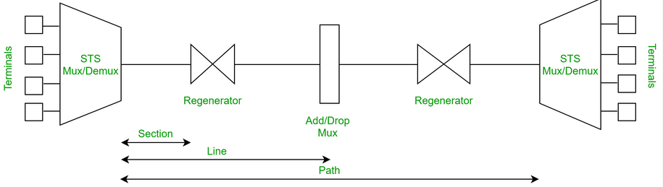

*Fig: simple diagram of SONET network*

**STS Multiplexer**

It Performs multiplexing of signals. It Converts electrical signal to optical signal. It marks the beginning points of SONET link. It multiplexes signals from multiple electrical sources and creates the corresponding optical signal.

**STS Demultiplexer**

It Performs demultiplexing of signals. It Converts optical signal to electrical signal. It marks the end points of SONET link. It demultiplexes an optical OC signal into corresponding optical signals.

**Regenerator**

It is a repeater, that takes an optical signal and regenerates (increases the strength) it. It also extends the length of the links.

**Add/Drop Multiplexer:**

It allows insertion and extraction of signals. It allows to add signals coming from different sources into a given path or remove a signal.

**SONET CONNECTIONS**

**Section:** Portion of network connecting two neighboring devices.

**Line:** Portion of network connecting two neighboring multiplexers.

**Path:** End-to-end portion of the network.

**SONET LAYERS**

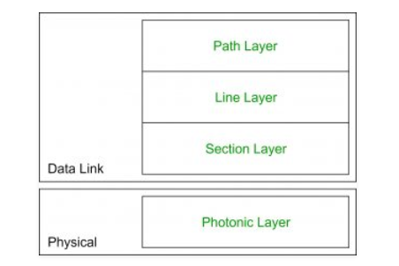

*Fig: SONET Layers*

**Path Layer**

It is responsible for the movement of signal from its optical source to its optical destination. STS Mux/Demux provides path layer functions. In this layer signals from multiple electrical sources converted into corresponding optical signal and also an optical signals are converted into corresponding electric signals.

**Line Layer**

It is responsible for the movement of signal across a physical line. STS Mux/Demux and Add/Drop Mux provides Line layer functions.

**Section Layer**

It is responsible for the movement of signal across a physical section. Each device of network provides section layer functions. Here overhead is added to the frame and control errors.

**Photonic Layer**

It corresponds to the physical layer of the OSI model. It includes physical specifications for the optical fibre channel (presence of light = 1 and absence of light = 0). It includes physical specifications for the optical fiber channel.

**Framing**

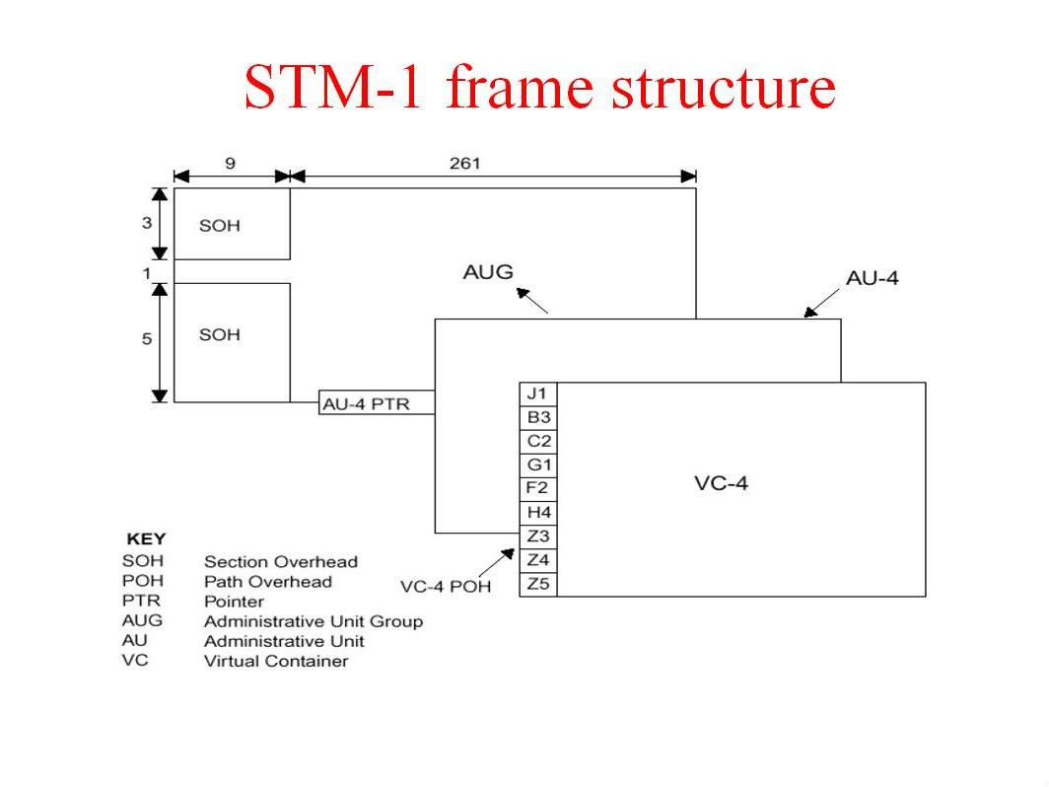

*Fig: STM-1 frame structure*

**Framing Technique:**

In packet-oriented data transmission, such as Ethernet, a packet frame usually consists of a header and a payload. The header is transmitted first, followed by the payload. In the case of an STS-1, the frame is 810 octets in size, while the STM-1/STS-3c frame is 2,430 octets in size. For STS-1, the frame is transmitted as three octets of overhead, followed by 87 octets of payload. This is repeated nine times, until 810 octets have been transmitted, taking 125 μs. Each byte in a SONET frame can carry a digitized voice channel. Bytes are transmitted from the left to the right and top to the bottom. STS-n signal is transmitted at a fixed rate of 8000 frames per second.

**STS (synchronous transport signal)**

It is mainly used by large telecom carriers. There are two ways to look at connection rates. On one hand, you have the STS and on the other the OC or optical carrier. STS-n signal is transmitted at a fixed rate of 8000 frames per second. STS-96 OC-96 has a rate of 4976.64 megabits per second. STS-12 OC-12 is at 622.08 megabits per second. STS-1 OC-1 is at 51.84 megabits per second.

**Advantages of SONET**

* Transmits data to large distances
* Low electromagnetic interference
* High data rates
* Large Bandwidth
* Better network reliability
* Lower equipment investment
* Better connectivity between different telecom carriers
* Highly flexible architecture which means that it can carry many applications created in the future too

**Disadvantages of SONET**

* No interoperable standard
* Tributary services require SONET mux services
* Low cost effective for low channel numbers.
* SONET/SDH network management system not well equipped to handle the DWDM method and management
* Bandwidth efficiency is a problem at higher capacity
* More overhead is required